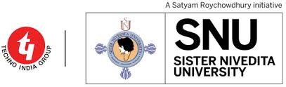

SISTER NIVEDITA UNIVERSITY

NEWTOWN, KOLKATA, WEST BENGAL

AWS DevOps Initiative

Sprint Documentation report

Team Information:
Team Name: Logic B
Team Members:
Suman Samanta
Simanta Ghosh
Manidipa Das
Zaid Ahmed
Sandip Das
Product owner: Manpreet Singh
Project Manager(PMs): 1. Janardhan A
2. Chandram S

Mentors: 1.Sneha Guhathakurta
2.Kanika Haruray
3. Aayushi Dhingra

Sprint Details:
Course: AWS Devops Initiative
Sprint Number: Sprint 1
Week: Week 1

